Record No: 0632
MARGARET HALL CLINCH (Daisy/Dick)

Younger dau of William Clinch (0633) of The Elms, Witney, Oxfordshire by his
wife Rachel Hall Wright, daughter of John Wright of Curbridge, Oxfordshire.

Birth: 16 Jul 1859 at Witney, Oxfordshire
Bapt: 24 Aug 1859, at St Mary’s Church, Witney
Marriage: 27 Aug 1879 at St Mary’s Church, Witney to Bellingham Arthur
Somerville (0631), Royal Irish Constabulary, son of Tenison Alan
Somerville (0591) by his wife,Cecilia Eliza, nee O’Connor (0592)
Death: 5 July 1949, at Clermont, Rathnew, Co Wicklow
Burial: 8 July 1949 at Rathnew Cemetery, Co Wicklow

Source: Somerville Index

Notes: Sister of Jack Clinch and Rachel Clinch,who married Tom Forshew.

Mother of:

William Arthur Tenison Bellingham Somerville(0660)
James Aubrey Henry Bellingham Somerville(0663)
Alan Everard Whichnour Bellingham Somerville(0666)
Gualter Hugh Rodger Bellingham Somerville(0667)
Reginald Malcolm John Bellingham Somerville(0670)
Cecilia Eliza Margaret Bellingham Somerville(0675)
Dorothy Alrewas Hester Bellingham Somerville(0677)
Vere Frances de Merlie Bellingham Somerville(0678)
Edeline Botelier Marjorie Bellingham Somerville(0680)

(Note for David Gilmour:
I have seen the notes in the Truell profile and comment as follows. The brewery was founded by John Williams Clinch, William Clinch’s father, indeed, possibly his father, I can check in the yard in due course; I will provide more information on this when I go into papers more deeply. I know there was the bank and several farms. There was also a brewery at Onchan in the Isle of Man, which had some connection. I don’t know the number of the house in Hollywell which had the school. I had heard the story about the gold coin and the bank. I didn’t realize she had been engaged twice before meeting BAS. The reason for going to the UK was her English patriotism, I am told; she evidently did say “my country needs me”. The reason Jack Clinch was disinherited was because he drank and, therefore, could not be involved in the management of the business. )

Margaret Hall Clinch was called Daisy before she was married and signed the series of four watercolours she painted as a teenager ‘Daisy Clinch’. After her marriage, she was always referred to by her husband BAS (0631) as ‘Dick’ and named that way in the catalogue of glass plates wherever she appears.

Daisy went to a school in Hollywell, in Oxford; Holywell runs parallel to the High Street, north of New College, leading from Broad Street to Long Wall Street. It is said that the school was unusually strict; she seemed to excel in the usual arts of that time. Examples of her needlework survived until recently, and some of her fine watercolours still do.

Erina Somerville(named Cis by her siblings, Aunt Amy by her nephews and nieces) went to the same school and was escorted on the journeys by one of her brothers, Henry or BAS. Daisy was engaged to be married to a Eugene de Ritson at an early age, but, on meeting BAS, broke it off. Amy and BAS went to stay in Witney with the Clinches between Monday 7 January 1878 and Sunday 3 February 1878 on which date BAS’ diary records he returned and “came back an engaged man having been engaged to Mr and Mrs Clinch’s second daughter Margaret Hall”.

After their wedding at Witney in August 1879, BAS and Daisy honeymooned in Paris; they returned to BAS’ District in Newtownards, Co Down. Thereafter they moved around the country wherever BAS was appointed, staying in rented accommodation until he retired, early through sickness, in 1891 at which point they were living at Friars Hill in Wicklow, BAS’ last District. They then seemed to have lived for perhaps two years in 82, Harcourt Street in Dublin while deciding where to go; by 1894, they were back in the Wicklow area renting Ballyhenry House near Ashford (1894) and Seaview in Wicklow(1895). BAS had bought Clermont in Rathnew in 1894, which required extensive renovation and improvement, so they continued to rent until they moved in in early 1895.

The regime at Clermont was strict. Children could only have either butter or jam; never both. Later on, men had one sausage; women half a sausage. Dick was extremely careful; look after the pennies, the pounds will look after themselves. Children were educated at home by governesses and tutors. Amusements were devised by themselves; hockey, tennis and rounders offered the only opportunity to meet outsiders. The boys enjoyed shooting and, down on the lakes, fishing and wild fowling. A stuffed sparrow hawk and kestrel, shot by Regi, when fourteen, stand on a shelf behind the writer.

Both BAS and Dick, as she was now known, suffered from ill health, on and off. He continued to have some sickness that had bothered him throughout his career; and within about 15 years he began to withdraw from meeting any outsiders at all. Regi said he used to stagger and fall( Reyniers Disease ?) and he was careful that he should not be seen lest it be thought he had been drinking. At the wedding of one of his daughters in 1912, he would not attend and in the wedding photograph, taken on the upper terrace, he is to be seen in the study window looking on. (WBRBS has this photograph and will identify the daughter when it comes to hand). Dick contracted Anthrax – how, it is not known; thereafter, from her photographs, she seemed to lack her former sparkle.

After BAS’ death in 1916, Dick lived on at Clermont. The car was stolen, with Langrell at the wheel, during the Troubles. When the IRA returned it, they were summoned to the drawing room and dressed down by the fearless lady of the house, who struck terror into the gunmen, proudly asserted that she was English, that her sons were all at the front and secured some form of undertaking that they and the family would not be targeted when they returned. It was customary for young army officers to be shot if found at home. Regi was ambushed on his motor bike at the top of Ballinabarney in 1916, before he went to the front, in the belief he was Pat.

After WW1 Dick travelled extensively; several times to India where the three elder boys, and Tetty and John either were, or had been, and twice to Regi in Kenya. The letters which David Gilmour has provided make it all seem as if the journeys of more than a month were a brief trip down the road !

After the second World War, when Clermont was closed and Dick was in England, sometimes in London, sometimes Oxford, sometimes Birmingham, she returned to Ireland and played weekly Bridge with Aileen Crofton of Inchinappa, Dottie Tottenham of Ballycurry, Henry and Patsy Truell of Clonmannon and others. It was a ritual; the teas were, to a small onlooker, scrumptious, but the regime had a distinct formality about it. The ritual for Wednesdays and Sundays between 1946 and 1949 was a trip down to the garden in the wheelchair, covered in a dun coloured corduroy material, and back again, Regi in control accompanied by Regi’s family when at home. The reward was the cream; even though on the turn for want of hygiene in the dairy. Dick was quite stern; she stared and tended to frighten people. She had a disconcerting habit of watching people eat; and constantly reprimanded Juanita for drinking her milk too quickly. It is difficult to imagine warmth; yet her letters are certainly warm and affectionate. At home she was conscious of her position as a ‘grande dame’, with a companion, but always in control herself. She held the keys of the store room to the day of her death. Bunt had tried to persuade her to sell Clermont after the war when there was a ready market among English people escaping the Labour Government and its hair shirt policies; no, I would seem a pauper !.

Dick was much respected by the locals. During WW1, she had provided help in one form or another to a sorely distressed village. It is said that she paid the wages of everyman who volunteered until the first pay cheque came through from the War Office. Rathnew and Newtown Mt Kennedy sent more men to the front, per head of population, than any other in the British Isles. This, however, was more a sign of the economic conditions of the time than of patriotism; nonetheless, the gentry provided example, both in those whom they sent out, and in the good works of those at home.

Dick died of pneumonia, the great killer of those times, in July 1949, shortly before her 90th birthday.

She was buried in the same grave, at Rathnew Cemetery, as her infant Truell grandchildren, rather than with BAS in Wicklow Churchyard as she had a fear of being buried over water. The church and churchyard at Wicklow are situated high above the Vartry River just before it enters Wicklow Harbour and the sea. A few years ago (2011) a portion of the eastern side of the churchyard suffered a landslide and collapsed down towards the river. The Somerville grave is at the western side. The name of the area near Rathnew, where the cemetery is situated, is called ‘Merrymeetings’. Irish funerals tend to be far larger than those in England. The funeral cortege, comprised of the people of Rathnew, filled the road from Clermont on the north side to Merrymeetings on the south side.

Dick’s memory lived on in Rathnew for many years.

WBRBS from personal knowledge and conversations with Regi, Honor and Dorothy Rooke; and from the Somerville Records.

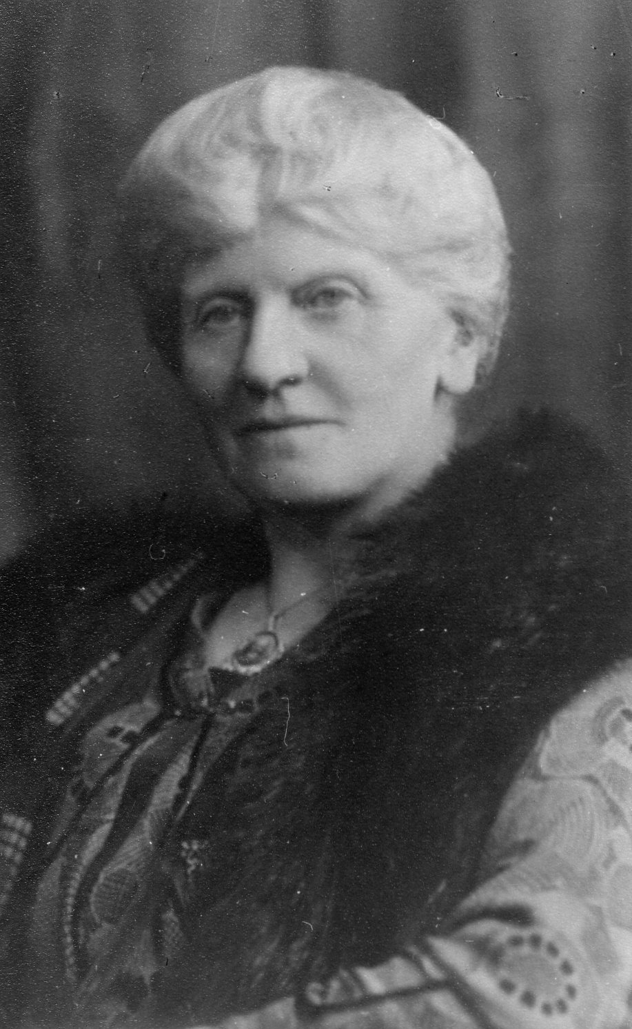
Margaret Hall Somerville (nee Clinch)

Union Castle Line
S-S “Llandovery Castle”
29 Aug 1925
Thursday Morning
9 am
My dearest de Merlie,

We have just passed through the Straits of Messina – it was very beautiful – there were a certain number of soft clouds + some mist in places, with bright sunshine in other parts & on the sea this was a joyful blue- and is still – which all added to the glory of it – at 4 o/c this morning a number of us got up to see Stromboli – which was in slight eruption. I could not have imagined anything like it – the huge tongues of flame boiling + boiling up, then a great burst which threw enormous boulders of lava up into the air which then poured down the side of the mountain – only to be followed by another burning stream. We were quite near to it all + at the time it was dark which added very much to the effect. I could never have imagined it and would not have missed it for anything. I only wished that some of you could have been here to enjoy it with me. It is much warmer now, we have a shiny soft wind – with bright sunshine – we could not wish for a more perfect day but I cannot thoroughly enjoy it without some of my dear ones with me. I cannot “warm” to strangers & there are only a very few on the boat who can talk to. Sometimes I go to see Mrs French & very much enjoy a gossip with her. I try to take some exercise walking round the deck - ten times is a mile – which I am afraid I never accomplish - & in the middle of the day it is impossible to walk – it is so crowded – we have only the one deck for every one and every thing: for games have to be got in somehow & we have over 90 children on board - at times the noise is deafening – then I go to my cabin for a little quiet – it is impossible to get it on deck. Some of the passengers wanted to get up to sports but had to give up the idea as there is no room – very often they cannot have here “deck tennis” – there is really [illegible] deck. I know in the 3rd class theirs have – but that is their only advantage – otherwise I should not care for it.

Saturday 31 Oct 1925
This is another joyful day but there is decidedly a strong roll – yesterday it was very rough – many of the passengers & most of the children felt it badly. I am thankful to say it makes no difference to me, except that it is very difficult to move about one falls over things. It calmed down in the day so I went and had a long gossip with Mrs French which I much enjoyed – she gives me so much information, about farming and their life in Kenya – it is all very much the same as Uncle Regi has let me into further details – she is beginning to look very tired and how it is hard work taking charge of their two little children on the boat when [illegible possibly ‘finding’] it is so difficult to manage & she has to do all the washing for them too as there is no laundry on board.

Will you ask mother, when she is down the town, if she will go to Barts and tell them to send me a tube of Borafax. I forgot to buy it – there is no hurry and I have plenty to last for some time, but I just like to have it by me - ask her to let me know what she pays – including postage - & I will give it to her later on.

We ought to arrive at Port Said every early in this evening, we have to do some [illegible] there but they say it will not take long. If we only stay short time I shall not go ashore – there is nothing to interest me there and I [illegible - ‘think on the boat one has to luncheon’ ?]

Will you give my best love to all darling child & keep a big share for yourself.

Always yr loving old
Grannie
Additional research by David Gilmour:
Borafax was a skin cream which is no longer on the market. It was made with boric acid, a weak anti-fungal,anti-biotic, and might have been used in case of bites or perhaps as an early form of sun cream. (source: internet)
CLERMONT
RATHNEW
Co. WICKLOW
26 Sept 1927

My dear de Merlie,

I feel more than guilty for not having answered your [illeg] nice letter long ago – somehow there is always so much to be done - + then one puts off writing.

I hear you had a wonderful holiday and then finished up at Swanage with the family, how you much have thoroughly enjoyed it all + I hear the change has done everyone good.

We have had Uncle Pat here for eight days – he had to leave on Wednesday evening for a course of lectures we wanted to attend in London – he is staying there now – he is looking better + I though him very much improved during the few days he was here – I just loved having him.

I am very much looking forward to seeing you all next month and hope to be with you midday on the 13th as Tettie + I cross now into Liverpool – she will [illeg] to London.

We are getting very busy now – there seems so much to be done before long – I cannot get through a great deal in the day - I get so tired.

Your dear Mother’s letter to Tettie arrived this morning – we were very glad to hear of you all – I expect you are busy at term-time again – I thought of you on Thursday morning starting off to College.

My love to you all + a big big share for your dear self,

Always your loving old,

Grannie

3rd Nov 1927
Thursday Evening

Saturday Since early yesterday morning it has been very rough & delayed as to such we do not get to Port Said until after 9 o/c tonight. G

My dear de Merlie

Here we are rushing now as fast as we can towards the East. We spent all Tuesday at Marseilles. Such crowds on the pier when we arrived, any amount of [..ing] , [.. ing] , selling fruit, music dancing + singing – all most amusing to watch. [illeg] + I took a short taxi drive through the town – just to see something of it – unfortunately all the shops were closed as it was All Saints Day – but we enjoyed the drive and it was very nice to get away from the ship for a short time – it is a very tiring life on board – always a [illeg] + bustle – there are so many moving about – it is quite impossible to get any real rest and there are children playing + [illeg] in every direction. Night is about as loud as day for there is dancing going on for a long time + cabin is small + very hot now we have the third person in it. She is somewhat large and an American – but she really tries to be nice + we quite like her, although we can’t help wishing to have the place to ourselves - In spite of all [illeg] I am feeling much better and really far more rested than when I left home.

For a few hours this morning, it tried to rain though it soon gave up the attempt which was the only time since we left Gib. Early yesterday morning we went thought the Straits of Bonifacio it was awfully pretty and very early this evening we went through the straits of Messina – We are due at Port Said on Saturday morning & expect to be there about 4 hours – after that we do not put in anywhere until we get to Bombay – so there will not be another chance of writing until then- we are due there on the 15th.

This day three weeks ago I arrived with you at Cheltenham – How I enjoyed those few days – it seems years ago – Please remember me to Grandpapa. My very best love to you all - + I shall think of you so much – but you must not trouble to write to me until the [illeg] when I should [illeg – love?] a letter.

Always your loving loving old,

Grannie

PS. Please tell Mother I am wishing for the best of the [games?].

Swiss Hotel
Delhi
Thursday
2ND Feb. 1928.

My darling de Merlie,

This morning I received your letter – it was so good of you to write to me when your time must be very much taken up with so many parties & other amusements and I am sure you want every spare moment to help mother who must have had a tremendous amount to do with Michael so ill and in [illeg] – I don’t know how she was able to write to me – it was sweet of her – her last weeks’ letter was delayed but I got the two today, - the [illeg – news?] cheered me wonderfully to find above all that Michael was better – and things settling down. You must have had a very very slow winter, I am quite sure you enjoyed the snow + ice – personally I dislike it very much and have always preferred warm weather – when we can get about so much easier and enjoy the country – which I love.

It has been quite cold here, it is gradually getting warmer – and we are now able to sit out in the middle of the day – every afternoon this week we have been watching a tennis tournament the finals will be tomorrow – then we get another better tournament which will be most interesting. On the 13th the Horse Show begins. We shall then get a good polo tournament. I think I enjoy watching polo more than anything. It is wonderful to see the ponies watching the ball – they appear quite as keen about it all as their riders – then it is so thrilling when they are galloping for all they are worth along the ground.

I have heard from Aunt Kitty that she is going home this year instead of their [inlaws] She is sailing with “China” on the 21ST of March so I have arranged to go to Secundarabad on the 1ST March until the 15^{th:} when I go on to Bombay & Tettie will meet me there – she will stay here while I am at Secunderabad. This will give to about twelve days there & about the same at Bombay.

I believe it is already quite hot in Bombay – and they have had to start fans - [illeg]... Tettie & i hope to rush up to [illeg] for me just to see the [illeg]. We shall probably only stay there one night, which will really give us two days there – it will be quite enough to see all we want.

I suppose you are now back at College and hard at work again – I have met out here a good many old Cheletenham College girls who always love to talk about it – and of course it is tremendously interesting to me.

I hear Major Hume is now in Delhi in the [illeg].I have not yet met him – he probably has not care to see anyone which is quite natural. I am more than sorry for him – it must all have been terrible.

I hear Billy [B___] is to go back to school again this tern – I should think it is much & happier for him – he seemed quite a “lost sheep” at home by himself – I am most thankful he is going – t[illeg] + Girlie seems to be a great deal better too.

I am writing this very hurriedly and there are people in and out – this is the worst of things on a Veranda, one can never get a really quiet time – everybody seems to know what you are doing + what you have + one hardly seems to have any real work to do – it may be well enough for a short time but it would be too dreadful to spend one’s life in this way – and have nothing to look back to – but regrets for wasted time .

Give my love to all – especially Mother - + keep lots for yourself darling Child

Forever always your loving old

Grannie

CLERMONT
RATHNEW
Co. WICKLOW

Tues Evg.
14 Aug 1928

Dearest de Merlie –
Many many happy returns of your birthday darling Child – I hope you will have every blessing + that life will be a joy to you and that your will help to make it the same for all your dear ones - & this prepare you for greater happiness afterwards.
You have made such a splendid effort to do what is right – go on darling in the same way + it will bring you such happiness.
I am sending you a little present with my very best love – I hope you will like it + when you wear it, you will be reminded of the good wishes + fond love of your old
Grannie

